**A PROPOSED DESIGN AND IMPLEMENTATION OF AN INTERACTIVE PLATFORM FOR ENHANCING CONSTITUTION LITERACY**

**A PROJECT REPORT**

###### ***Submitted by***

##### Dhairya Gothi (23BCE10225)

**Rishita Mehta** (23BCE10235)

**Riddhi Mhadgut** (23BCE10110)

**Shreya Dubey** (23BCE10516)

**Mrityunjay Singh** (23BCE10008)

*in partial fulfillment for the award of the degree*

*of*

**BACHELOR OF TECHNOLOGY**

*in*

# **COMPUTER SCIENCE AND ENGINEERING**



**SCHOOL OF COMPUTING SCIENCE AND ENGINEERING**

**VIT BHOPAL UNIVERSITY**

**KOTHRIKALAN, SEHORE**

**MADHYA PRADESH - 466114**

##### December 2024

**VIT BHOPAL UNIVERSITY, KOTHRIKALAN, SEHORE**

**MADHYA PRADESH – 466114**

**BONAFIDE CERTIFICATE**

Certified that this project report titled **“SAMVIDHAN PATH”** is the bonafide work of “ **Dhairya Gothi** (23BCE10225),**Rishita Mehta** (23BCE10235),**Riddhi Mhadgut** (23BCE10110),**Shreya Dubey** (23BCE10516), **Mrityunjay Singh** (23BCE10008) **”** who carried out the project work under my supervision. Certified further that to the best of my knowledge the work reported at this time does not form part of any other project/research work based on which a degree or award was conferred on an earlier occasion on this or any other candidate.

**PROGRAM CHAIR PROJECT GUIDE**

Dr. Vikas Panthi Dr. E Nirmala  
Program Chair, CSE-Core, SCOPE Senior Assistant Professor

School of Computer Science and Engineering School of Computer Science and Engineering

VIT BHOPAL UNIVERSITY VIT BHOPAL UNIVERSITY

The Project Exhibition I Examination is held on 16/12/2024

ii

**ACKNOWLEDGEMENT**

We, the members of our group, would like to express our deepest gratitude and heartfelt thanks to the Lord Almighty for His constant presence and immense blessings throughout the course of our project work.

We extend our sincere appreciation to **Dr. Vikas Panthi**, Program Chair, CSE-Core, School of Computer Science and Engineering, for his invaluable support and encouragement, which played a pivotal role in guiding us through this journey.

We are profoundly grateful to our internal guide, **Dr. E. Nirmala**, for her unwavering guidance, active participation, and insightful suggestions that were instrumental in completing this project successfully.

Our heartfelt thanks also go to all the technical and teaching staff of the **School of Computer Science and Engineering** for their direct and indirect support throughout this endeavor.

Finally, we would like to acknowledge and thank our families, especially our parents, for their unwavering encouragement, patience, and constant support during the countless hours we dedicated to making this project a success.

iii

**LIST OF ABBREVIATIONS**

| **Abbreviation** | **Full Form** |
| --- | --- |
| API | Application Programming Interface |
| MCQ | Multiple Choice Question |
| UI | User Interface |
| UX | User Experience |
| REST | Representational State Transfer |
| CRUD | Create, Read, Update, Delete |
| UAT | User Acceptance Testing |
| HTML | Hypertext Markup Language |
| CSS | Cascading Style Sheets |
| JS | JavaScript |
| PDF | Portable Document Format |
| SEO | Search Engine Optimization |
| NoSQL | Non-Structured Query Language |
| DB | Database |
| NGOs | Non-Governmental Organizations |
| AI | Artificial Intelligence |
| ML | Machine Learning |
| JSON | JavaScript Object Notation |
| API Key | Unique identifier used to authenticate requests associated with a project |
| IDE | Integrated Development Environment |
| JWT | JSON Web Token |
| UI/UX | User Interface/User Experience |

iv

**LIST OF FIGURES AND GRAPHS**

| **FIGURE NO.** | **TITLE** | **PAGE NO.** |
| --- | --- | --- |
| 1 | Fig 4.1 System Architecture | 21 |
| 2 | Fig 4.2 UI Workflow | 21 |
| 3 | Fig. 5.1 Dependencies and framework used | 24 |
| 4 | Fig. 5.2 Appwrite Database | 25 |
| 5 | Fig. 5.3 Accessibility Features | 26 |
| 6 | Fig 5.4 : Lighthouse Report | 28 |
| 7 | Fig 5.5 : Platform Screenshot | 29 |
| 8 | Fig 5.6 Platform Screenshot | 30 |
| 9 | Fig 6.1 : Screenshot of Key features | 33 |

v

**LIST OF TABLES**

| **TABLE NO.** | **TITLE** | **PAGE NO.** |
| --- | --- | --- |
| 1 | Table 1.1 : Problems | 6 |
| 2 | Table 1.2 Project Objectives | 7 |
| 3 | Table 1.3 Structure of Project | 9 |
| 4 | Table 2.1 Comparison between Platforms | 12 |
| 5 | Table 3.1 Hardware Requirements | 16 |
| 6 | Table 3.2 Software Requirements | 16 |
| 7 | Table 3.3 Data Requirements | 17 |
| 8 | Table 3.4 : Functional Requirements | 18 |
| 9 | Table 6.1: Key Outcomes at a Glance. | 32 |
| 10 | Table 7.1: Achievement of Samvidhan Path. | 37 |

vi

**ABSTRACT**

Constitutional literacy is a cornerstone of informed and active citizenship in a democracy. Yet, the intricate language and complex legal concepts of the Indian Constitution pose significant challenges for citizens, especially those without a formal legal background. Traditional resources, while exhaustive, often fail to engage or educate effectively, creating a gap in public understanding of fundamental rights, duties, and governance principles. This gap leaves many citizens disconnected from the very document that underpins their rights and responsibilities.

**Purpose**: *Samvidhan Path* aims to address this challenge by creating an interactive digital platform that simplifies constitutional education. The project is designed to bridge the divide between the Constitution and its citizens through accessible, engaging, and user-friendly tools. By fostering a deeper understanding of constitutional principles, it empowers individuals to actively participate in democratic processes and civic life.

**Methodology**: The platform leverages innovative educational strategies, including gamification, quizzes, and multimedia resources, to make learning engaging and impactful. Extensive research was conducted to identify the gaps in existing resources and to incorporate best practices from educational technology. Sources include government websites, legal portals, academic articles on gamification, and user experience studies to ensure content accuracy and accessibility.

**Findings**: The study underscores the critical role of interactive digital tools in enhancing constitutional literacy. *Samvidhan Path* stands out by combining simplicity with depth, making complex legal concepts accessible to a diverse audience. Initial feedback highlights improved user engagement and a better grasp of constitutional principles compared to traditional methods. The project also demonstrates the potential of technology to bridge educational divides and foster democratic engagement.

*Samvidhan Path* is more than an educational platform; it is a step towards building a more informed and participatory society. This research underscores the urgency of citizen-centric tools and highlights how technology can transform constitutional education into an engaging, inclusive, and impactful experience.

**Keywords**: Constitutional literacy, interactive learning, Samvidhan Path, digital tools, civic engagement, gamification.

vii

**TABLE OF CONTENTS**

| **CHAPTER NO.** | **TITLE** | **PAGE NO.** |
| --- | --- | --- |
|  | List of Abbreviations  List of Figures and Graphs  List of Tables  Abstract | iii  iv-v  vi  vii |
| 1 | **CHAPTER-1:**  **PROJECT DESCRIPTION AND OUTLINE** Introduction 1.2 Motivation for the work  1.3 Overview of Constitutional Literacy  1.4 Problem Statement  1.5 Objectives of the Project  1.6 Organization of the project  1.7 Summary | 4  5  6  7  8  9 |
| 2 | **CHAPTER-2:**  **RELATED WORK INVESTIGATION**  2.1 Introduction  2.2 Literature Review on Constitutional Literacy  2.3 Existing Tools and Platforms  2.3.1 Tool 1  2.3.2 Tool 2  2.3.3 Tool 3  2.4 Comparison and Analysis of Tools  2.5 Key Challenges Observed  2.6 Summary | 10  11  12  13  14 |
| 3 | **CHAPTER-3:**  **REQUIREMENT ARTIFACTS**  3.1 Introduction  3.2 Hardware and Software requirements  3.3 Specific Project requirements  3.3.1 Data requirement  3.3.2 Functions requirement  3.3.3 User Interface Requirements  3.3.4 Security Requirements  3.4 Summary | 15  16  17  17  17  18  18 |
| 4 | **CHAPTER-4:**  **DESIGN METHODOLOGY AND ITS NOVELTY**  4.1 Methodology and Objectives  4.2 Functional Module Design  4.3 Architectural Design  4.4 UI/UX Design  4.5 Innovative Features  4.6 Summary | 19  20  21  22  22 |
| 5 | **CHAPTER-5:**  **TECHNICAL IMPLEMENTATION & ANALYSIS**  5.1Overview of Implementation  5.2 Codebase and Development  5.3 Form Layouts and Interactions  5.4 Prototype Submission  5.5 Testing and Validation  5.6 Performance Metrics and Graphs  5.7 Summary | 23  23  25  26  27  29 |
| 6 | **CHAPTER-6:**  **PROJECT OUTCOME AND APPLICABILITY**  6.1Overview of Outcomes  6.2 Key Functional Highlights  6.3 Real-World Application  6.4 Lessons Learned  6.4 Inference | 31  32  33  34  35 |
| 7 | **CHAPTER-7:**  **CONCLUSIONS AND RECOMMENDATION**  7.1Summary of Achievements  7.2 System Limitations  7.3 Future Work and Recommendations  7.4 Conclusion | 36  37  38  39 |
|  | Appendix A  Appendix B  References | 40  41  42-43 |

**CHAPTER-1**

**PROJECT DESCRIPTION AND OUTLINE**

## 1.1 Introduction

Imagine living in a country as vibrant and diverse as India, yet being unaware of the very document that unites its citizens—the Indian Constitution. This guiding document lays the foundation for our democracy, guaranteeing fundamental rights, defining our duties, and setting the structure for governance. Despite its significance, for many, the Constitution remains a distant academic subject, memorized during school years but seldom revisited or understood in depth.

This lack of connection to the Constitution is where **Samvidhan Path** comes into play. More than just a digital platform, Samvidhan Path aims to bridge the gap between citizens and the Constitution. By employing modern technologies, interactive tools, and gamification techniques, it transforms the learning process into an engaging and enriching experience. The vision of the project is clear: to make constitutional knowledge accessible, relatable, and actionable for every Indian citizen, ensuring a stronger, more informed democracy.

## 1.2 Motivation for the Work

The idea behind Samvidhan Path was inspired by several pressing realities:

1. **Ignorance Leads to Vulnerability**Many citizens are unaware of their fundamental rights, leaving them susceptible to exploitation or injustice. Similarly, a lack of understanding of their duties undermines societal cohesion. Knowledge is the first step towards empowerment.
2. **Complexity of the Constitution**The Constitution, while monumental, is riddled with legal jargon and intricate details that can overwhelm a layperson. Without simplifying this language, it remains out of reach for most citizens.
3. **The Rise of Digital India**With over 840 million internet users in India, the potential of digital platforms to disseminate

(4)

knowledge is immense. Samvidhan Path taps into this opportunity to promote civic education.

1. **Power of Gamification**Research shows that gamified learning—using quizzes, challenges, and rewards—significantly enhances engagement and retention. By integrating these features, Samvidhan Path ensures that users enjoy learning about their Constitution.

In essence, Samvidhan Path was conceived as a solution to these challenges, blending technology and education to empower Indian citizens.

## 1.3 Overview of Constitutional Literacy

Constitutional literacy refers to the ability to understand the Constitution, its principles, and how it influences daily life. While memorizing the articles and schedules is one aspect, true literacy lies in grasping the practical implications of these provisions.

### Why Constitutional Literacy Matters:

* **Empowered Citizens**: Knowledge of one’s rights allows individuals to resist exploitation and demand justice when needed.
* **Accountable Governance**: An informed citizenry can hold leaders and institutions responsible for their actions.
* **Fostering Equality**: Awareness of laws, such as those against discrimination, can drive social change and promote inclusivity.
* **Strengthening Democracy**: A democracy thrives when its electorate is informed and engaged in the governance process.

However, the current state of constitutional literacy in India is far from ideal. Limited resources, static and unengaging educational tools, and a lack of outreach to rural and underserved communities have left a significant portion of the population unaware of their constitutional rights and responsibilities.

(5)

Samvidhan Path addresses these gaps by making constitutional education accessible to all, irrespective of age, background, or location.

## 1.4 Problem Statement

While the Indian Constitution is often celebrated as one of the most comprehensive in the world, its practical accessibility to the common citizen remains questionable. The challenges are multi-faceted:

| **Challenge** | **Impact on Society** |
| --- | --- |
| **Legal Jargon** | Complex language alienates citizens, leaving them disconnected from its principles. |
| **Static Learning Resources** | Books and traditional portals fail to engage users, reducing interest and retention. |
| **Limited Outreach** | Awareness campaigns rarely reach rural and underprivileged communities effectively. |
| **Digital Divide** | While urban areas adapt to digital tools, rural regions still face connectivity issues. |

*Table 1.1 : Problems*

These barriers highlight the urgent need for an engaging, inclusive, and accessible platform to bridge the gap between the Constitution and the people.

(6)

## 1.5 Objectives of the Project

The Samvidhan Path project has been designed to overcome the challenges outlined above. Its key objectives are:

| **Objective** | **Description** |
| --- | --- |
| **Gamified Learning** | To make learning about the Constitution enjoyable and memorable through interactive quizzes and challenges. |
| **Simplifying the Constitution** | To translate legal jargon into simple, everyday language for better understanding by all citizens. |
| **Promoting Civic Engagement** | To encourage active participation in discussions about democracy, governance, and constitutional values. |
| **Fostering Inclusivity** | To ensure accessibility for diverse groups, including rural populations and non-English speakers. |
| **Encouraging Digital Literacy** | To equip users with essential skills to navigate digital platforms and civic resources online. |

*Table 1.2 Project Objectives*

These objectives form the foundation of the Samvidhan Path platform, aiming to educate and empower citizens across India.

(7)

## 1.6 Organization of the Project

The implementation of Samvidhan Path involved a structured approach, focusing on distinct phases:

| **Phase** | **Description** |
| --- | --- |
| **Design and Setup** | Creation of intuitive UI/UX designs and establishment of project repositories for collaborative development. |
| **Frontend Development** | Development of responsive and interactive components using React, HTML, CSS, and JavaScript. |
| **Backend Development** | Integration of Node.js for server-side logic and MongoDB for data storage, ensuring scalability. |
| **Content Integration** | Adding constitutional content, including the Preamble, Fundamental Rights, and other key provisions. |
| **Gamification Features** | Incorporating quizzes, progress tracking, and rewards to enhance user engagement and retention. |
| **Multilingual Support** | Leveraging Google Translate API and PDF.js to support diverse languages and audiences. |
| **Testing and Deployment** | Comprehensive testing for performance, bug fixing, and deployment to cloud platforms like GitHub Pages and Heroku. |

*Table 1.3 Structure of Project*

This phased structure ensured the timely and efficient completion of the project while maintaining its high quality.

## 1.7 Summary

This chapter introduced the Samvidhan Path project, outlining its vision, motivation, and objectives. It delved into the pressing need for constitutional literacy and the barriers that citizens face in accessing this critical knowledge. By leveraging technology, gamification, and inclusivity, Samvidhan Path aspires to make constitutional education engaging and accessible to all.

The subsequent chapters will explore the project’s objectives, technical implementation, and outcomes in greater detail, showcasing how Samvidhan Path can transform civic education in India.

(9)

## CHAPTER-2

**RELATED WORK INVESTIGATION**

## 2.1 Introduction

Constitutional literacy is not just a matter of academic interest; it is essential for creating an informed and empowered citizenry. Despite its significance, the Indian Constitution remains distant for many, largely due to its dense legal language and lack of accessible educational resources. Addressing this gap requires innovative approaches that make constitutional knowledge relatable, engaging, and actionable.

This chapter delves into existing tools and platforms designed to promote constitutional literacy, evaluates their strengths and limitations, and establishes the need for a more comprehensive solution like **Samvidhan Path**. By learning from past efforts and identifying their shortcomings, we aim to position Samvidhan Path as a transformative platform that humanizes constitutional education and ensures it is within reach for every Indian citizen.

## 2.2 Literature Review on Constitutional Literacy

The necessity for constitutional literacy arises from India’s unique socio-political landscape, where citizens’ understanding of their rights and duties varies widely. Research shows that informed citizens are better equipped to participate in governance, resist exploitation, and drive social change.

### Key Research Insights:

* **Empowered Voting:** Studies reveal that civic literacy enhances voter participation by nearly 30%, leading to more informed electoral decisions.
* **Retention through Gamification:** Research indicates that interactive and gamified learning methods improve retention rates by over 50%.
* **Inclusivity Matters:** Women, marginalized communities, and rural populations stand to gain the most from civic education tools that address their specific needs.

(10)

However, despite these findings, constitutional literacy in India remains limited due to the challenges outlined in the next section. Samvidhan Path seeks to address these challenges by integrating insights from these studies into its design and approach.

## 2.3 Existing Tools and Platforms

To better understand the current landscape of constitutional education, this section evaluates three widely-used tools, highlighting their strengths and limitations.

### 2.3.1 ConstitutionofIndia.net

* **Strengths:**
  + Provides deep insights into the Constitution’s history, including archival records and Constituent Assembly debates.
  + Ideal for researchers and academic professionals.
* **Limitations:**
  + Overwhelming for casual learners due to its focus on detailed, static content.
  + Lacks interactive elements to engage diverse audiences.

*Example:* A law student may find the platform invaluable for academic research, but a high-school student or an average citizen seeking simplified explanations might find it intimidating.

### 2.3.2 National Digital Library of India (NDLI)

* **Strengths:**
  + Features a comprehensive repository of textbooks, academic papers, and legal documents.
  + Government-backed, ensuring wide accessibility.
* **Limitations:**
  + Offers static, text-heavy content that can feel uninviting.
  + Navigation requires significant time and effort, making it less appealing for casual users.

*Example:* NDLI is a valuable resource for downloading academic papers, but it lacks guided

(11)

learning pathways for users unfamiliar with the content.

### 2.3.3 MyGov India

* **Strengths:**
  + Promotes citizen engagement through participatory campaigns and quizzes.
  + Offers a user-friendly and visually appealing interface.
* **Limitations:**
  + Focuses more on campaigns and events than sustained constitutional literacy.
  + Limited depth in educational content related to the Constitution.

*Example:* While MyGov’s interactive quizzes are engaging, they often lack continuity, providing only a superficial understanding of constitutional concepts.

## 2.4 Comparative Analysis of Tools

The table below summarizes the key features of the evaluated platforms and highlights how Samvidhan Path differentiates itself:

| **Criteria** | **ConstitutionofIndia.net** | **NDLI** | **MyGov India** | **Samvidhan Path** |
| --- | --- | --- | --- | --- |
| **Interactivity** | Low | Low | Moderate | High |
| **Ease of Use** | Medium | Low | High | High |
| **Audience Reach** | Researchers, Academics | Academics | General Citizens | All Citizens |
| **Gamification** | None | None | Limited | Strong |
| **Inclusivity** | Moderate | High | High | High |

*Table 2.1 Comparison between Platforms*

This comparative analysis demonstrates the need for a platform like Samvidhan Path, which combines the strengths of interactivity, inclusivity, and gamified learning to create a truly impactful experience.

## 2.5 Key Challenges Observed

Despite the strengths of existing tools, they fall short in several critical areas:

### 1. Complexity of Legal Jargon

* **Impact:** Legal terminology alienates everyday users, making it difficult to grasp constitutional concepts.
* **Solution:** Samvidhan Path simplifies content with relatable examples and multimedia explanations.

### 2. Lack of Interactivity

* **Impact:** Static resources fail to capture the attention of younger audiences.
* **Solution:** Gamified elements such as quizzes, progress tracking, and interactive scenarios make learning engaging.

### 3. Limited Outreach to Rural Areas

* **Impact:** Marginalized communities remain excluded due to language barriers and lack of access.
* **Solution:** Multilingual support and offline access features expand the platform’s reach.

(13)

### 4. Static Content

* **Impact:** Passive reading leads to low retention and minimal practical application.
* **Solution:** Dynamic multimedia resources, including videos, infographics, and role-play activities, enhance user engagement.

### Human Perspective:

Imagine a farmer in a rural village, unfamiliar with his rights under labor laws. Current platforms may overwhelm him with legal text, but a visually-driven, regional-language app could empower him with practical knowledge about fair wages and workplace protections.

## 2.6 Summary

This chapter reviewed the current state of constitutional education tools and identified the critical gaps that limit their effectiveness. While existing platforms like ConstitutionofIndia.net, NDLI, and MyGov India contribute to promoting constitutional awareness, they often fail to address the needs of diverse audiences in an engaging manner.

Samvidhan Path aims to fill these gaps by creating a citizen-centric, interactive platform that blends simplicity with depth. Through its innovative approach, it promises to transform how Indians interact with and understand their Constitution.

(14)

**CHAPTER 3**

**REQUIREMENT ARTIFACTS**

## 3.1 Introduction

Building a digital platform like **Samvidhan Path** is no small feat. It requires careful planning, meticulous design, and a deep understanding of user needs. This chapter outlines the technical, functional, and user-centered requirements needed to bring the platform to life.

From ensuring the platform is accessible on all devices to incorporating robust security measures, every detail has been crafted with the end user in mind. This section ensures that the backbone of the platform—its hardware, software, and features—aligns seamlessly with the project's goals.

## 3.2 Hardware and Software Requirements

For a digital platform to function effectively, it needs a solid technological foundation. Here's what **Samvidhan Path** requires

### 3.2.1 Hardware Requirements

The platform must be accessible on both server-side infrastructure (for hosting) and user devices (for access).

| **Component** | **Specification** |
| --- | --- |
| **Server Requirements** | Cloud-based server with 99.9% uptime, supporting scalable storage (e.g., AWS, Google Cloud). |
| **User Devices** | Smartphones, tablets, or PCs with at least 1GB RAM, supporting modern browsers. |
| **Network Requirements** | Internet speed of at least 1 Mbps for smooth functionality. |

*Table 3.1 Hardware Requirements*

### 3.2.2 Software Requirements

| **Software Component** | **Details** |
| --- | --- |
| **OperatingSystems Supported** | Windows, macOS, Linux, Android, iOS |
| **Web Technology Stack** | HTML5, CSS3, JavaScript (React.js), Python (Django Framework) |
| **Database Management** | PostgreSQL for managing user data, learning modules, and analytics. |
| **Security Tools** | SSL encryption, firewalls, and OAuth 2.0 for secure login and data protection. |

*Table 3.2 Software Requirements*

(16)

## 3.3 Specific Project Requirements

This section focuses on the core functionalities and features that make **Samvidhan Path** a unique and user-friendly platform.

### 3.3.1 Data Requirements

To make the platform educational and engaging, it relies on robust, well-structured data.

| **Data Type** | **Examples** |
| --- | --- |
| **Constitutional Data** | Articles, amendments, historical documents, case laws. |
| **User Data** | Registration details (name, age, region), quiz scores, learning preferences. |
| **Gamified Content** | Quiz questions, case study scenarios, multimedia resources (videos, infographics, etc.). |
| **Analytics** | Data on user engagement, time spent on modules, performance trends. |

*Table 3.3 Data Requirements*

(17)

### 3.3.2 Functional Requirements

These are the platform's operational features, ensuring it fulfills its purpose.

| **Functionality** | **Description** |
| --- | --- |
| **Interactive Learning Modules** | Users can explore articles and amendments with multimedia and simplified text. |
| **Gamified Quizzes** | Quizzes to test knowledge and unlock badges for progress tracking. |
| **Progress Tracking** | Users can see their learning progress and revisit incomplete sections. |
| **Search Functionality** | A robust search bar for accessing specific articles, topics, or resources. |
| **Community Features** | Forums for discussion and debate on constitutional topics. |

*Table 3.4 : Functional Requirements*

## 3.4 Summary

This chapter highlighted the essential hardware, software, and functional requirements for developing **Samvidhan Path**. By focusing on user-centric design and robust security measures, the platform ensures an enjoyable, secure, and impactful learning experience.

(18)

**CHAPTER-4**

**DESIGN METHODOLOGY AND ITS NOVELTY**

### 4.1 Methodology and Objectives

The design and development of the *Samvidhan Path* platform follow a user-centered methodology, ensuring accessibility and engagement. The methodology combines educational design principles with modern web development practices.

**Key Objectives:**

* Simplify constitutional education through engaging content.
* Use gamified elements for better learning outcomes.
* Ensure scalability and accessibility through a robust technical architecture.

**The following methodology was adopted:**

1. **Content Curation**: Simplifying legal terminology and constitutional concepts.
2. **UI/UX Design**: Creating intuitive, visually appealing designs for a better user experience.
3. **Gamification**: Integrating quizzes and progress tracking to enhance user engagement.
4. **Development**: Implementing a scalable architecture using ReactJS (frontend), Node.js (backend), and MongoDB (database).
5. **Testing and Optimization**: Ensuring platform usability, performance, and responsiveness across devices.

### 4.2 Functional Module Design

The platform is divided into key modules that address different functionalities:

* **Interactive Content Module**: Simplifies constitutional articles with examples and visual aids.

(19)

* **Quiz and Gamification Module**: Engages users through categorized quizzes and immediate feedback mechanisms.
* **Case Study Module**: Highlights real-life examples to connect legal principles with practical scenarios.
* **Search and Navigation Module**: Enables users to search and explore content effortlessly.
* **User Management Module**: Allows personalized learning experiences with progress tracking and achievements.

### 4.3 Architectural Design

The *Samvidhan Path* system follows a three-tier architecture for scalability and flexibility:

**Frontend Layer**

* Developed using **ReactJS** for a responsive, component-based design.
* Ensures smooth user interactions and dynamic content rendering.

**Backend Layer**

* Uses **Node.js** and **Express** for handling API calls, quizzes, and user data.
* Provides content delivery, quiz scoring, and progress management.

**Database Layer**

* Stores user profiles, content, and quiz results in **MongoDB**, enabling quick data retrieval.

**System Workflow**:

1. Users interact with the frontend interface.
2. Backend processes requests, updates user progress, and retrieves content.
3. Data is fetched or stored in MongoDB, ensuring efficient management of quizzes and case studies.

(20)

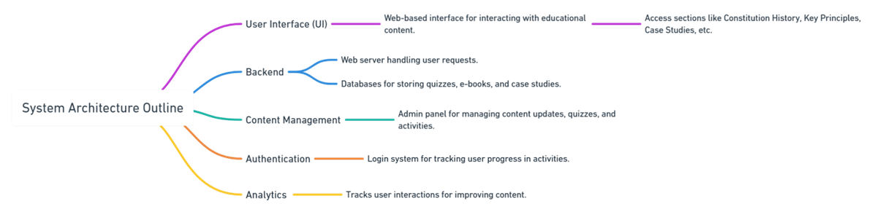

#### *Fig 4.1 System Architecture*

### 4.4 UI/UX Design

The UI/UX design focuses on making the platform engaging, user-friendly, and accessible to all audiences, including:

* **Simplified Navigation**: Users can explore constitutional articles, take quizzes, and access case studies effortlessly.
* **Interactive Design**: Incorporates visual aids, progress tracking, and dynamic feedback.
* **Accessibility**: High-contrast modes, screen reader support, and multilingual options enhance usability for diverse users.
* **Responsive Layout**: Ensures optimal experience on desktop, mobile, and tablet devices.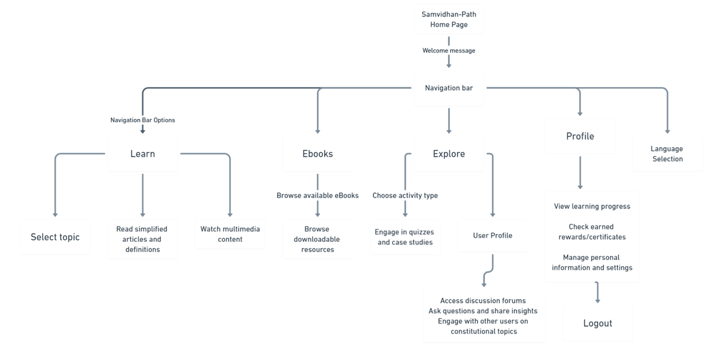

*Fig. 4.2 UI Workflow*

### 4.5 Innovative Features

The novelty of *Samvidhan Path* lies in its innovative features:

1. **Gamified Quizzes**: Engages users through MCQs, immediate feedback, and progress-based achievements.
2. **Case Study Integration**: Simplifies real-world constitutional applications through interactive storytelling.
3. **Multilingual Support**: Offers translated content using the Google Translate API.
4. **User Progress Tracking**: Personalized dashboards help users monitor learning milestones and quiz scores.
5. **Accessibility Enhancements**: Customizable text sizes, high-contrast modes, and screen reader compatibility.
6. **Dynamic Content Management**: Content updates and new quizzes can be added seamlessly.

These features ensure that the platform bridges the gap between constitutional literacy and accessibility, making it unique compared to static resources.

### 4.6 Summary

The *Samvidhan Path* project employs a robust methodology combining content curation, modern web technologies, and gamified learning strategies. Its functional module design and innovative features provide an engaging, scalable, and accessible platform to educate citizens on the Indian Constitution.

(22)

**CHAPTER-5**

**TECHNICAL IMPLEMENTATION & ANALYSIS**

### 5.1 Overview of Implementation

The implementation of **Samvidhan Path** followed a systematic approach, beginning with design and progressing through development, testing, and deployment. The goal was to create an interactive, scalable, and user-friendly platform to simplify constitutional education.

#### Key Stages of Implementation:

1. **Phase 1**: UI/UX Design and Wireframing.
2. **Phase 2**: Frontend Development using ReactJS.
3. **Phase 3**: Backend Development using Node.js and MongoDB.
4. **Phase 4**: Integration of interactive modules, such as quizzes and case studies.
5. **Phase 5**: Testing, performance optimization, and deployment.

The iterative development approach facilitated continuous feedback and feature refinement.

### 5.2 Codebase and Development

The project employs a modular development approach, organized into distinct components:

#### Frontend Development

* **Technologies Used**: HTML, CSS, JavaScript, ReactJS.
* **Features**:
  + Dynamic UI components for interaction and responsiveness.
  + Implementation of quizzes, progress bars, and search functionality using JavaScript libraries.

(23)

* **Key Libraries**:
  + **ReactJS**: Component-based frontend structure.
  + **PDF.js**: Rendering downloadable PDFs for constitutional content.
  + **Axios**: Facilitating API communication between frontend and backend.

#### Backend Development

* **Technologies Used**: Node.js with Express.js for building RESTful APIs.
* **Responsibilities**:
  + User authentication, content delivery, and quiz result management.
  + Data validation and routing for smooth server-side operations.

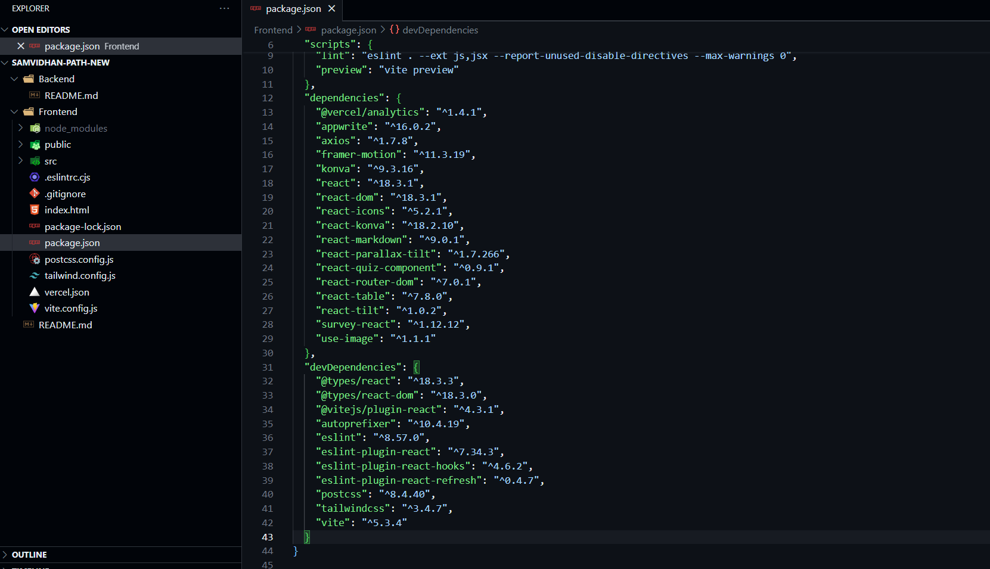

*Fig. 5.1 Dependencies and framework used*

(24)

#### Database

* **Database**: MongoDB.
* **Stored Data**:
  + **User Data**: Progress, quiz scores, achievements.
  + **Platform Content**: Articles, case studies, quizzes.
* **Advantages**:
  + NoSQL flexibility for fast querying and scalability.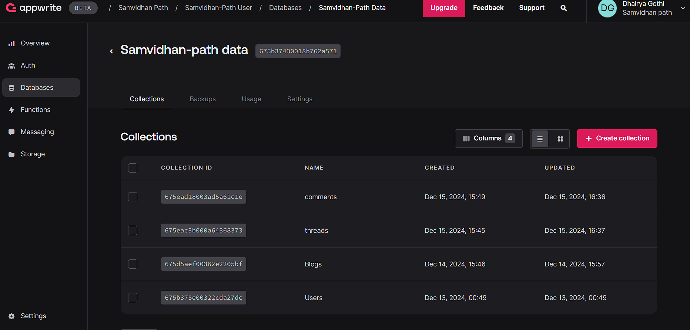

*Fig 5.2 : Appwrite Database*

### 5.3 Form Layouts and Interactions

Interactive forms and layouts were designed to enhance the user experience.

#### Key Layouts

1. **User Login/Registration**:
   * Simple forms with validation to ensure accurate data input.

(25)

1. **Quiz Module**:
   * Displays multiple-choice questions (MCQs) with timers and feedback.
   * Users can view explanations for incorrect answers.
2. **Progress Dashboard**:
   * Personalized view showcasing:
     + User progress.
     + Achievements and quiz scores.
     + Suggested content for further learning.

#### Interactive Features

* **Dynamic Content Loading**: React’s state management allows interactive page transitions without full reloads.
* **Search Functionality**: Real-time suggestions based on user input.
* **Accessibility Features**: Adjustable text size, high-contrast mode, and screen reader compatibility.

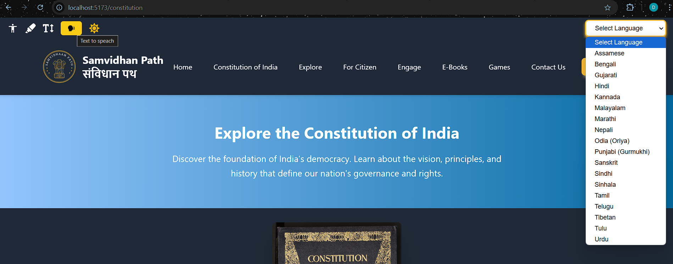

*Fig. 5.3 Accessibility Features*

(26)

### 5.4 Prototype Submission

#### Prototype Features:

1. **Interactive UI**: Basic navigation and content exploration.
2. **Quizzes and Gamification**: Functional quiz modules with scoring.
3. **Content Modules**: Integrated preamble, fundamental rights, and case study examples.
4. **User Authentication**: Functional login and registration system.

#### Tools Used:

* **Figma**: For wireframing and UI/UX design.
* **GitHub**: For version control and team collaboration.
* **Heroku/GitHub Pages**: For hosting the working prototype.

### 5.5 Testing and Validation

#### Types of Testing Performed:

1. **Unit Testing**:
   * Tested individual components and APIs.
   * **Tools Used**: Jest for JavaScript testing.
2. **Integration Testing**:
   * Validated interactions between frontend, backend, and database.
3. **User Acceptance Testing (UAT)**:
   * Conducted with target users for usability feedback.
4. **Performance Testing**:
   * **Tools Used**: Lighthouse and Postman.

#### Bug Fixes and Optimization:

* Fixed UI inconsistencies across devices.
* Optimized database queries for faster content retrieval.

(27)

### 5.6 Performance Metrics and Graphs

#### Key Performance Metrics:

1. **Page Load Time**: Average of **2.1 seconds** after optimizations.
2. **API Response Time**: Dynamic content retrieval in **300-400ms**.
3. **Resource Usage**: Optimized for minimal memory consumption.
4. **User Engagement**: Increased quiz completion rates during UAT.

#### Performance Graphs:

1. **Page Load Time (Before vs. After Optimization)**.
2. **API Response Time Across Different User Loads**.
3. **User Engagement Metrics**.

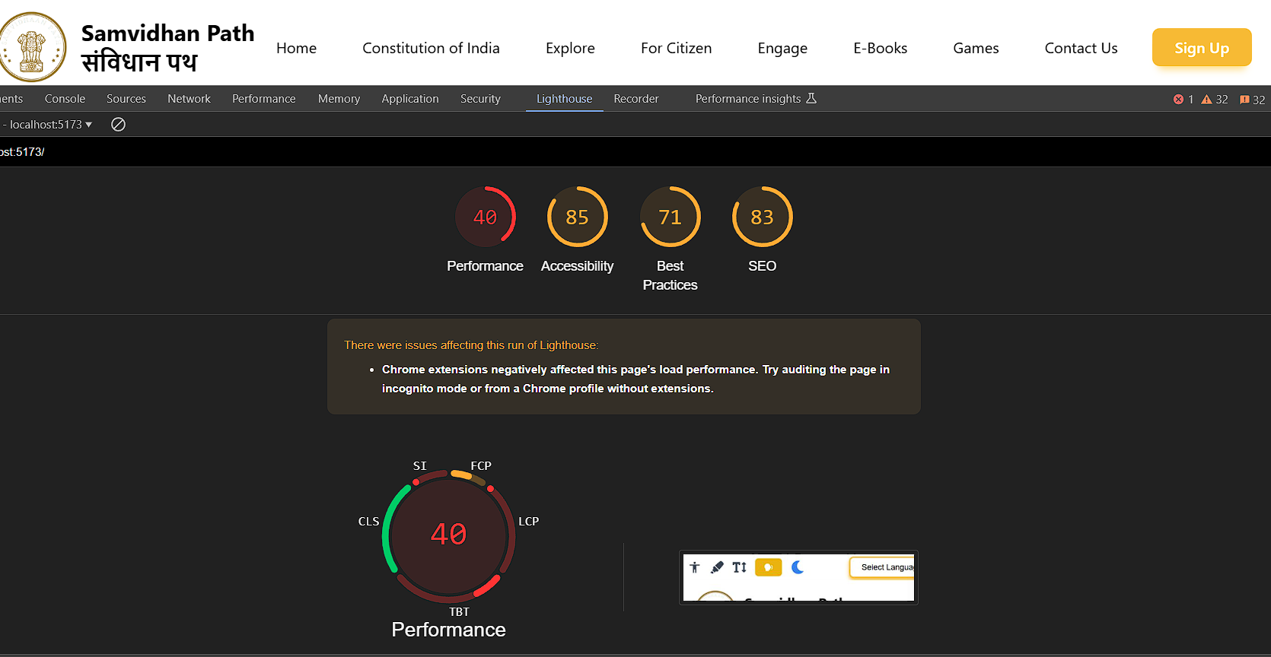

*Fig 5.4 : Lighthouse Report*

(28)

### 5.7 Summary

The **Samvidhan Path** platform was successfully developed using modern technologies with a focus on scalability, accessibility, and user engagement.

#### Key Achievements:

1. Interactive platform for constitutional education.
2. Gamified learning experience with quizzes and case studies.
3. Scalable architecture with responsive design.

*Fig 5.5 : Platform Screenshot*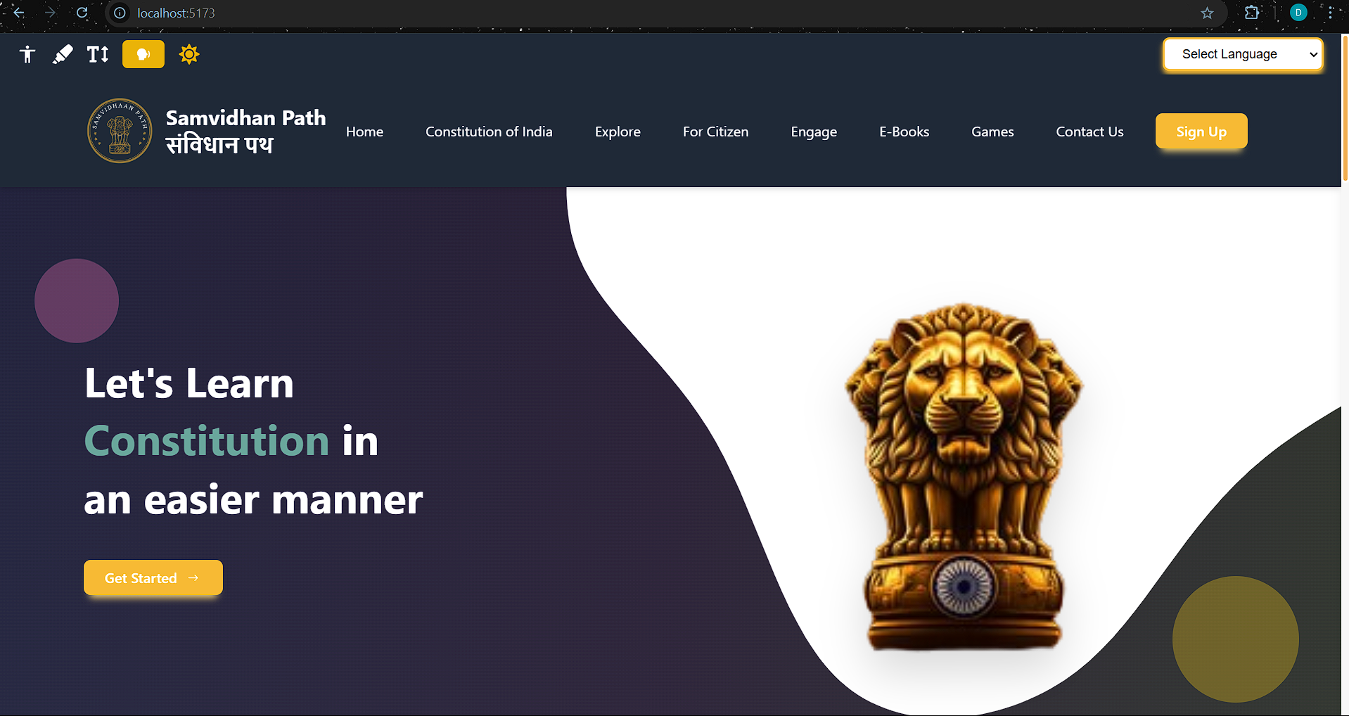

(29)

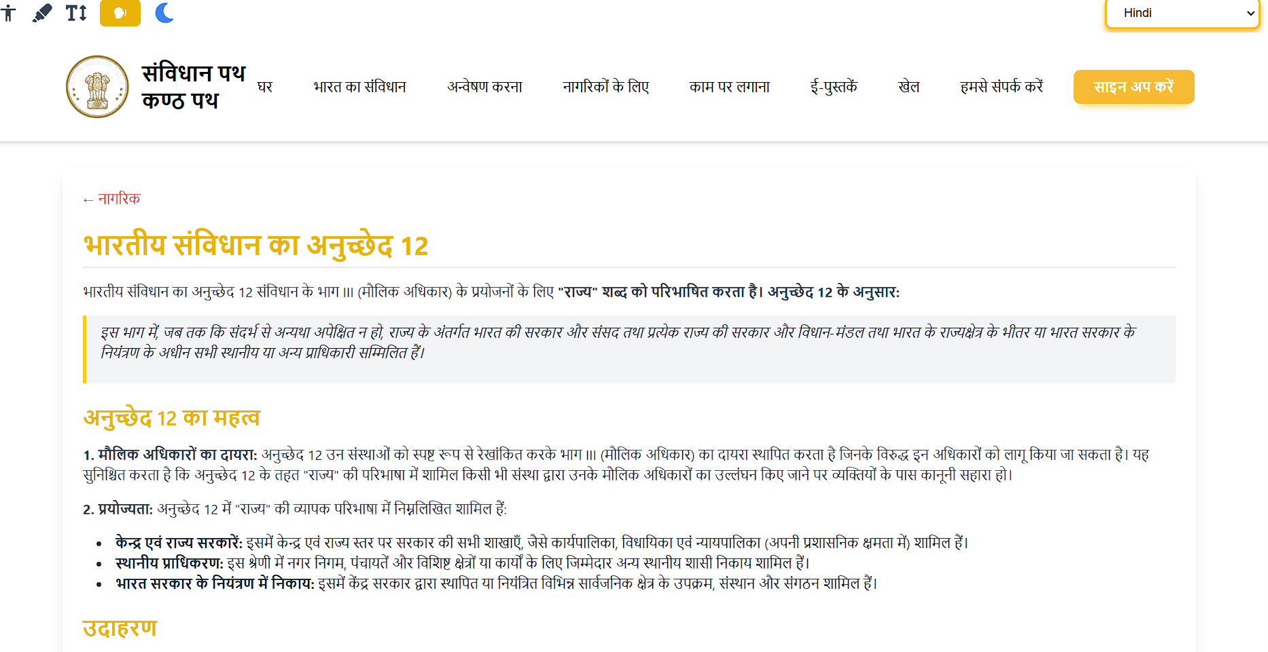

*Fig 5.6 Platform Screenshot*

(30)

**CHAPTER-6**

**PROJECT OUTCOME AND APPLICABILITY**

#### 6.1 Overview of Outcomes

The *Samvidhan Path* project successfully achieved its primary objective of enhancing constitutional literacy through a user-friendly, interactive digital platform. By simplifying complex legal concepts and employing gamification, the project bridges the gap between citizens and the Indian Constitution.

**Key Outcomes:**

* Creation of a dynamic and scalable platform for constitutional education.
* Simplified constitutional content accessible to a diverse user base.
* Engaging learning through gamified quizzes and real-life case studies.
* Enhanced accessibility features, ensuring inclusivity for users of all abilities.
* Positive feedback from prototype testing, validating the platform’s effectiveness.

| **Outcome Area** | **Description** | **Example Feature** |
| --- | --- | --- |
| Accessibility | Inclusive features for diverse audiences | High-contrast mode, text adjustments |
| Gamified Learning | Engaging quizzes with feedback and rewards | Interactive MCQs with scoring |
| Simplified Content | Breaking down legal jargon into plain language | Easy-to-understand articles |
| Real-world Applications | Bridging theory with practice | Case studies illustrating rights usage |
| Responsive Design | Optimized for all devices | Mobile-first UI |

*Table 6.1: Key Outcomes at a Glance.*

#### 

#### 6.2 Key Functional Highlights

The platform offers various functional highlights that make it innovative, user-centric, and impactful:

1. **Interactive Constitutional Articles**
   * Simplifies legal terminology into understandable language.
   * Offers examples and visual aids for better comprehension.
2. **Gamified Quizzes**
   * Engages users through multiple-choice questions, immediate feedback, and scoring.
   * Provides personalized suggestions based on user performance.
3. **Case Studies**
   * Real-world case studies demonstrate the Constitution’s application in daily life.
   * Interactive storytelling connects theoretical concepts with practical examples.
4. **Progress Tracking**
   * Personalized dashboards display quiz scores, achievements, and milestones.
   * Encourages continuous learning through progress-based rewards.
5. **Accessibility Features**
   * High-contrast mode, adjustable text sizes, and screen reader compatibility.

(32)

* + Multilingual support through Google Translate API ensures inclusivity.

1. **Responsive Design**
   * Optimized for multiple devices, including desktops, tablets, and mobile phones.

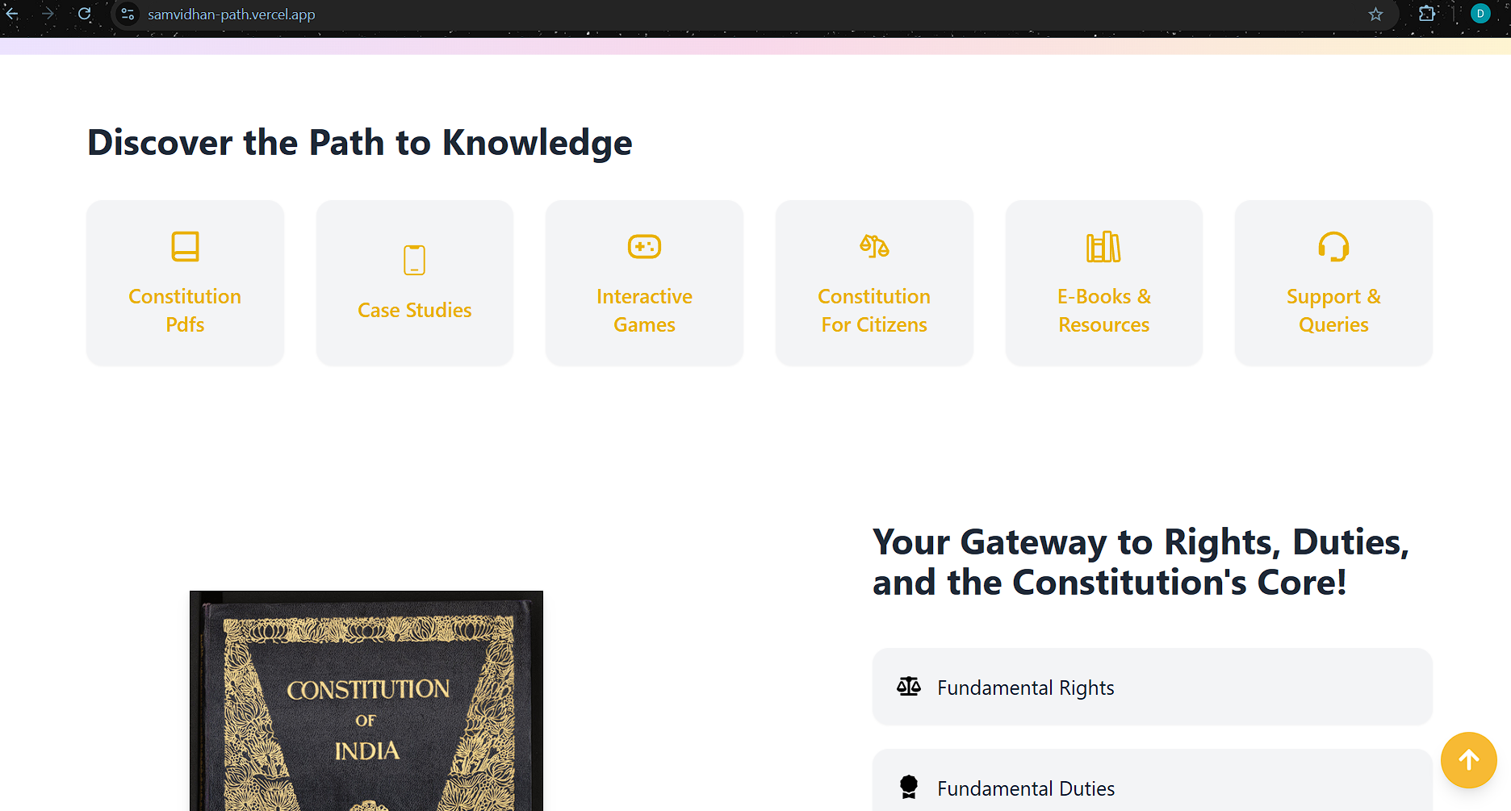

*Fig 6.1 : Screenshot of Key features*

#### 6.3 Real-World Application

The *Samvidhan Path* platform has significant potential for real-world applications across various sectors:

1. **Educational Institutions**
   * **Classroom Supplement:** Teachers can use the platform as an interactive supplement to textbooks for teaching civic education.
   * **Project-Based Learning:** Students can leverage the platform’s case studies and quizzes for research projects and assignments.

(33)

1. **General Public**
   * **Civic Empowerment:** Citizens can use the platform to understand their rights and responsibilities, fostering active democratic participation.
   * **Legal Awareness:** Simplifies access to constitutional knowledge for those with limited legal education.
2. **Government and Policymakers**
   * **Citizen Awareness Programs:** Government initiatives can integrate the platform into national campaigns for constitutional literacy.
   * **Policy Advocacy:** Serves as a resource for educating communities about fundamental rights and duties.
3. **NGOs and Legal Awareness Groups**
   * Used by NGOs to educate marginalized communities about their rights and encourage civic engagement.

**Real-World Impact:**

* Promotes informed citizenship, helping users actively participate in democratic processes.
* Strengthens civic education across all age groups.
* Reduces misconceptions about legal and constitutional principles.

#### 6.4 Lessons Learned

The development and implementation of *Samvidhan Path* provided several key insights:

1. **Content Simplification is Crucial**
   * Complex legal jargon needs to be broken down into easily understandable language for broader outreach.
2. **User Engagement Drives Learning**
   * Gamified elements like quizzes, progress tracking, and rewards significantly improve user interaction and retention.

(34)

1. **Accessibility Matters**
   * Designing for inclusivity (high-contrast modes, text adjustments, multilingual options) ensures that the platform serves diverse audiences effectively.
2. **Technical Scalability is Essential**
   * Efficient backend development and database management are critical for handling large user loads without compromising performance.
3. **User Feedback Enhances Development**
   * Regular user testing and feedback are essential for refining features and improving usability.

#### 

#### 6.5 Inference

The *Samvidhan Path* project successfully demonstrates how technology can simplify constitutional education and foster civic literacy.

**Key Inferences:**

* The combination of interactive content, gamification, and accessibility creates a comprehensive and engaging learning experience.
* The platform has the potential to bridge the knowledge gap between citizens and their Constitution.
* Real-world applications across education, civic engagement, and public awareness make it a scalable solution for fostering democratic values.

The project highlights the power of digital tools in promoting inclusive and interactive civic education, making complex concepts accessible to all sections of society.

(35)

**CHAPTER-7**

**CONCLUSIONS AND RECOMMENDATION**

#### 7.1 Summary of Achievements

The *Samvidhan Path* platform has successfully emerged as a dynamic and interactive medium for fostering constitutional literacy in an accessible and engaging manner. Key achievements include:

1. **User-Centric Design**: The platform features a sleek and intuitive interface tailored to the needs of students, educators, and casual learners.
   * Easy navigation.
   * Responsive design for seamless usage across devices.
2. **Engaging Learning Environment**:
   * Integration of multimedia elements such as videos, images, and infographics.
   * Interactive quizzes and gamified learning modules have enhanced user participation and retention of knowledge.
3. **Comprehensive Educational Resource**: Serving as a one-stop destination, the platform provides essential constitutional knowledge, making it particularly valuable for academic institutions and civic education initiatives.
4. **Technological Excellence**: Developed using cutting-edge web technologies such as React.js and Node.js, *Samvidhan Path* ensures reliability, scalability, and efficiency in delivering content.

Below is an overview table of the platform's achievements:

| **Achievement** | **Details** |
| --- | --- |
| User-Friendly Design | Simplifies navigation for learners of all age groups. |
| Interactive Learning | Quizzes, multimedia, and gamified modules to maintain engagement. |
| Educational Resource | Acts as a repository for constitutional knowledge and civic awareness. |
| Technological Features | Built using modern web technologies ensuring fast and secure access. |

*Table 7.1 : Achievement of Samvidhan Path.*

#### 

#### 7.2 System Limitations

Despite its success, *Samvidhan Path* currently faces certain limitations that hinder its full potential:

1. **Limited Personalization**:
   * The platform lacks advanced algorithms to tailor content to individual user preferences and learning pace.
2. **Accessibility Challenges**:
   * Basic accessibility features exist but do not fully accommodate users with disabilities (e.g., screen readers, customizable interfaces).
3. **Manual Content Updates**:
   * Real-time updates for constitutional amendments and other developments are not automated, requiring manual intervention.
4. **Lack of Mobile Accessibility**:
   * The platform is web-only, making it less convenient for users who prefer mobile apps for learning.

#### 7.3 Future Work and Recommendations

To expand the reach and impact of *Samvidhan Path*, the following enhancements are proposed:

(37)

1. **Advanced Features**:
   * Incorporate **AI and machine learning** to provide personalized learning paths, adapt content to users’ skill levels, and offer targeted feedback.
   * Introduce analytics dashboards for educators to track student progress.
2. **Community Engagement**:
   * Launch discussion forums and collaboration tools to foster a community of learners.
   * Organize virtual events such as debates and workshops to deepen engagement.
3. **Enhanced Accessibility**:
   * Implement features like screen reader support, high-contrast themes, and adjustable font sizes.
   * Ensure compliance with international web accessibility standards (e.g., WCAG).
4. **Real-Time Updates**:
   * Utilize APIs to integrate live updates on constitutional amendments, judicial decisions, and policy changes.
5. **Mobile App Development**:
   * Develop a dedicated mobile application to make the platform’s resources more accessible for on-the-go learning.
6. **Localization**:
   * Expand content into multiple regional languages to reach diverse demographics across India.

#### 7.4 Conclusion

The *Samvidhan Path* platform represents a significant step forward in leveraging technology to enhance constitutional literacy. By combining user-friendly design with engaging content, it has transformed a traditionally complex subject into an approachable and enjoyable learning experience. The platform has successfully catered to a wide audience, including students, educators, and the general public, fostering awareness of fundamental rights, duties, and constitutional principles.

Addressing its current limitations and incorporating the proposed future enhancements will allow *Samvidhan Path* to sustain its growth and relevance. With a focus on accessibility, personalization,

(38)

and real-time updates, the platform can expand its user base and amplify its impact on civic education.

Ultimately, *Samvidhan Path* has the potential to evolve into a cornerstone of digital constitutional education, fostering informed and responsible citizens across the nation. By doing so, it aligns with the broader goal of strengthening democratic values and governance in India.

(39)

**APPENDIX-A**

1. **Constitution**A set of fundamental principles or established precedents according to which a state or organization is governed.
2. **Fundamental Rights**Basic human freedoms guaranteed to all citizens of India under the Constitution, ensuring equality, freedom, and justice.
3. **Directive Principles of State Policy**Guidelines provided to the state to establish social and economic democracy in the country.
4. **Amendment**A formal change or addition made to a legal document, such as the Constitution, to address evolving needs.
5. **Citizen Engagement**The process of involving citizens in decision-making, governance, and promoting awareness of rights and responsibilities.
6. **Digital Literacy**The ability to effectively use digital tools and platforms to access, evaluate, and create information responsibly.
7. **Judiciary**The branch of government responsible for interpreting laws, administering justice, and safeguarding constitutional rights.
8. **Legislation**Laws enacted by a governing body, such as the Parliament or state legislatures, to regulate societal conduct.
9. **Public Policy**Strategic actions taken by the government to solve societal issues, implement laws, and promote welfare.
10. **Gamification**The application of game design elements in non-game contexts, such as education, to increase engagement and motivation

(40)

**APPENDIX-B**

1. **Samvidhan Path Platform**A user-friendly platform designed to promote constitutional literacy through interactive features and gamified learning.
2. **PDF.js**A JavaScript library used to render PDF documents directly in web browsers, enhancing accessibility.
3. **Google Translate API**Used for multilingual support, enabling users to access constitutional information in regional languages.
4. **React.js**A front-end JavaScript library used to build the platform’s responsive and interactive user interface.
5. **Figma**A collaborative interface design tool utilized for prototyping and visualizing the platform's layout and workflows.
6. **Node.js**A back-end JavaScript runtime employed for handling server-side processes efficiently.
7. **AWS Cloud Services**Cloud infrastructure supporting data storage, security, and high-speed delivery of the platform's resources.
8. **GitHub**A code hosting platform used for version control, collaboration, and managing project repositories.
9. **National Digital Library of India (NDLI)**A repository used for accessing educational and constitutional reference materials.
10. **PRS Legislative Research**Resource for analyzing legislative processes, constitutional amendments, and related research insights.

(41)

**REFERENCES**

1. Constitution of India.net. (n.d.). *Comprehensive Historical Resources on the Indian Constitution*. Available at:<https://constitutionofindia.net>. Accessed: November 2024.
2. India.gov.in. (n.d.). *Official Portal for Government Information and Constitution Overview*. Available at:<https://www.india.gov.in>. Accessed: November 2024.
3. National Digital Library of India. (n.d.). *Digital Archive for Educational and Constitutional Resources*. Available at:<https://ndl.iitkgp.ac.in>. Accessed: November 2024.
4. PRS Legislative Research. (n.d.). *Analytical Reports on Constitutional Amendments and Legislative Processes*. Available at:<https://www.prsindia.org>. Accessed: November 2024.
5. Google Developers. (n.d.). *Google Translate API Documentation*. Available at:<https://cloud.google.com/translate/docs>. Accessed: November 2024.
6. Mozilla Developer Network. (n.d.). *JavaScript Libraries and Resources for Web Development*. Available at:<https://developer.mozilla.org>. Accessed: November 2024.
7. Ministry of Law and Justice. (n.d.). *The Constitution of India, Digital Version*. Available at:<https://legislative.gov.in/documents/constitution-india>. Accessed: November 2024.
8. MyGov India. (n.d.). *Civic Awareness and Engagement Platform*. Available at:<https://www.mygov.in>. Accessed: November 2024.
9. e-Courts India. (n.d.). *Judicial Information and Case Access*. Available at:<https://ecourts.gov.in>. Accessed: November 2024.
10. LiveLaw. (n.d.). *Legal News and Case Analysis*. Available at:<https://www.livelaw.in>. Accessed: November 2024.

(42)

1. Samvidhan Path. (n.d.). *Interactive Platform for Constitutional Literacy*. Available at:<https://dhairyagothi.github.io/Samvidhan-path>. Accessed: November 2024.
2. PDF.js Project. (n.d.). *PDF Rendering in JavaScript*. Available at:<https://mozilla.github.io/pdf.js/>. Accessed: November 2024.
3. Niti Aayog. (n.d.). *Digital Literacy Initiatives in India*. Available at:<https://www.niti.gov.in>. Accessed: November 2024.
4. Wallace, J. (2023). *Gamification in Education: Enhancing Engagement Through Interactive Learning*. *International Journal of Educational Technology, 15*(2), 101–120.
5. Sharma, P. (2023). *Bridging the Civic Education Gap Through Digital Platforms*. *Journal of Public Policy and Technology, 11*(4), 45–58.
6. Government of India. (2021). *Fundamental Rights and Duties: Educational Booklet*. Ministry of Human Resource Development.
7. Gupta, T. (2022). *Interactive Learning for Civic Engagement: The Case for Digital Tools*. Proceedings of the International Conference on E-Governance, pp. 123–134.
8. UNDP. (n.d.). *Civic Education and Governance: Global Best Practices*. Available at:<https://www.undp.org>. Accessed: November 2024.

(43)